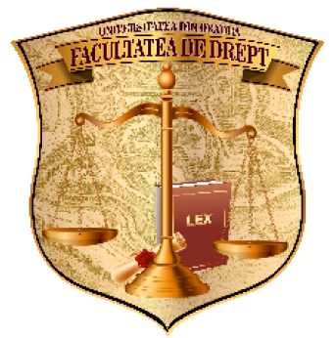  FACULTATEA DE DREPT  Centrul de Cercetare în Științe Juridice și administrative | ROMÂNIA  MINISTERUL EDUCAŢIEI NAŢIONALE  UNIVERSITATEA DIN ORADEA  FACULTATEA DE DREPT  C.P. nr. 114, Oficiul Poştal 1, Str. Gen. Magheru, nr. 26, Oradea, România  Tel./fax +40 259 479.980  E-mail: law@uoradea.ro, www.uoradea.ro | 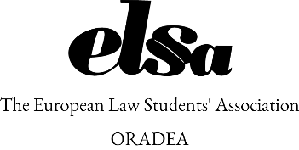

INVITATION
FACULTY OF LAW - UNIVERSITY OF ORADEA,
in partnership with E.L.S.A Oradea
have the great pleasure to invite you to the
NATIONAL CONFERENCE WITH THE INTERNATIONAL PARTICIPANTION:
“TODAY'S STUDENTS OF TOMORROW”,
(2nd Edition)
The conference will be held from May 30-31 2019, at the "Gheorghe Şincai" County Library in Oradea, the Romanian Army Street, no. 1 / A.
The scientific event is addressed to students of Law and Administrative Sciences - bachelor and master degree, benefiting from the participation of invited students from the country and abroad, and will have in its structure a student`s conference and activities of the interactive workshops type, the manifestation wishing to represent a space of dialogue and development of students and master students.

The student conference will have two sections (May 30, 2019):
- the LAW section on the topic: INFLUENCE OF NEW TECHNOLOGIES ON LAW
- the PUBLIC ADMINISTRATION section on the topic: THE INFLUENCE OF NEW TECHNOLOGIES ON PUBLIC ADMINISTRATION.

In the workshops, with the themes: New Challenges In The Legal Professions (lawyer, notary); New Challenges In The Activity Of The Civil Servant, will include law professors who are legal practitioners, legal specialists (lawyer, notary) and civil servants who will share with students specific aspects of their professional activity.

There will also be a training course on Personal Development - Public speaking, with the participation of a guest trainer.

The deadline for joining the conference is May 6, 2019 at: laviniachipea@gmail.com. Enrollment will be done with the work written in extenso, the editorial conditions being inserted below.

Between 6 - 20 May 2019, the works will be subjected to a selection and evaluation process, respecting the standards of a national conference. Only the selected papers will be presented at the conference held on May 30, 2019.

Hoping to receive soon the confirmation of your participation in the conference, we assure you of our highest consideration!

For more information:
- please visit the Faculty of Law`s website: www.drept.uoradea.ro
- at the same time, you can also contact the event coordinators:
- Associate Professor Lavinia Onica-Chipea, email: laviniachipea@gmail.com
- Lecturer Diana Cîrmaciu, email: dcirmaciu@gmail.com

Conditions for writing the paper: - The title and content of the paper should fit into the proposed theme for the two areas; - The paper will be written in MSWORD, in Romanian, in A4 format; - The consulted and used bibliography will be quoted in accordance with scientific rigor, and the final bibliography will be placed at the end of the paper. - The paper should be in the range of 4 - 8 pages; - The works can be done in co-authorship - up to 2 coauthors; - A presentation of the paper will be supported by a graphical presentation in MS PowerPoint.

