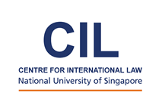
TEACHING AND RESEARCHING INTERNATIONAL LAW IN ASIA
The Centre for International Law at the National University of Singapore will be hosting a conference from 21 to 22 June 2018 on “Teaching and Researching International Law in Asia” (TRILA). The broad purposes of the Conference are to assess the current state of Teaching and Research in International Law in Asia, to identify commonly experienced challenges for teachers of international law in the region, and to formulate a programme of further action and activities to assist individuals in their teaching and research. This Conference follows in the footsteps of the successful Conference held on the same topic in Singapore in 2001. It also complements the ongoing work of the Asian Society of International Law.
The Conference will be preceded by a Junior Faculty Workshop on the 20th of June, which is directed at exploring the challenges junior faculty confront at the beginning of their careers in establishing themselves as teachers and in developing a scholarly agenda.
Further information about these events and how to participate is available here.

