 | Keynote speaker  Stefan Larsson  Lund University  Sweden  Conceptions in the Code  The role of metaphors for understanding and regulating technological change

Further participants of the workshop:

Péter Mezei  University of Szeged  Hungary  D.ownloading  O.ften  I.s  T.errible |  | Stefano Carabetta  University of Messina  Italy  Frontiers and metaphors of civil liability | 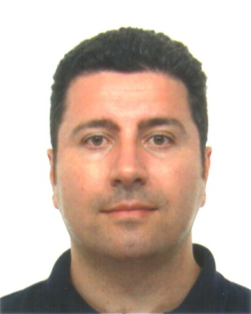

Date: February 8, 2018, 10:00 – 14:00

Venue: Conference room (3rd floor) 6720 Szeged, Tisza Lajos krt. 54. See Google Maps.

To register for the event please contact Péter Mezei at mezei@juris.u-szeged.hu

