УНИВЕРЗИТЕТ У НОВОМ САДУ, ПРАВНИ ФАКУЛТЕТ  21000 Нови Сад, Трг Доситеја Обрадовића 1  Србија | 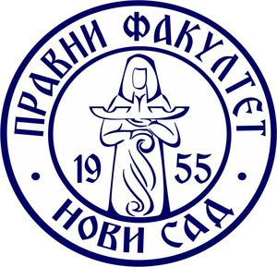 | UNIVERSITY OF NOVI SAD, FACULTY OF LAW  21000 Novi Sad, Trg Dositeja Obradovića 1  Serbia
Tel. (+381 -21) 485 30 40, 635 00 23, Fax (+381 -21) 450 427, www.pf.uns.ac.rs, e-mail: dekanat@pf.uns.ac.rs

Faculty of Law University of Novi Sad will host an international scientific conference The Legal Aspects of Migrations in the Region – the Balkan Route on 20 February 2018.

The Conference will concentrate on legal aspects of migrations in the territory of the Balkans and Southeast Europe. Working languages of the Conference will be Serbian and English.

Registration fee for participants is 30 EUR. Accommodation and travel costs are borne by participants.

Those interested in taking part in the Conference are kindly asked to fill in and submit the registration form which could be found on the web-site dedicated to the Conference (accessible through the Faculty’s web-site) by 15 December 2017 as well as to send the title and an abstract of the prospective paper to the following e-mail address:
konferencija.migracije@pf.uns.ac.rs.

Additional information can be found on the Conference’s web-site.

